The manometer below can be used to accurately measure very small differ- ences between the pressures pL and pR. There are two fluids in the system with specfic weights γA “ ρAg and γB “ ρB g (note that ρB ą ρA, since the “B” fluid sits under the “A” fluid).

When pL “ pR, then h “ 0 and H “ 0. But when pL ą pR, both h and H grow as shown in the figure. If the two tanks at the top of the apparatus have a very large cross-sectional area compared to the cross-sectional area of the U-tube, the the distance h is negligible compared to H.

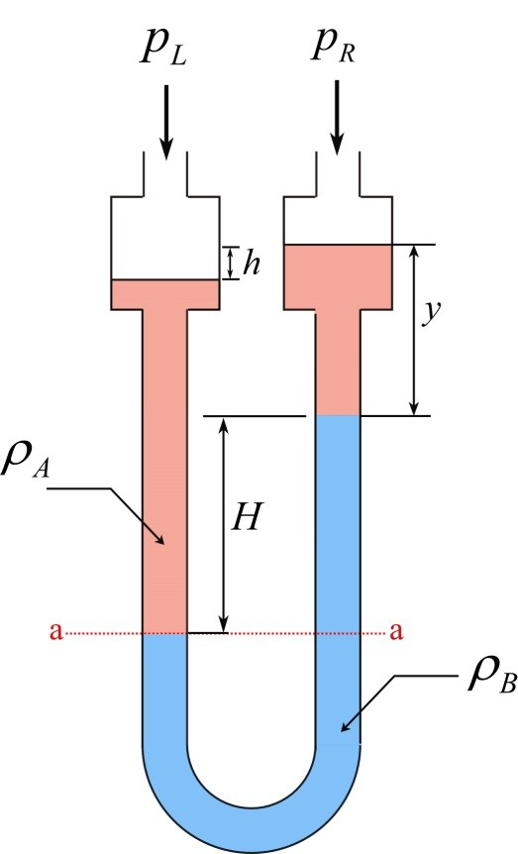

- Determine an analytical expression for the distance H as a function of
∆p, γA, and γB . Assume that h is so small that you can neglect it entirely.

- Let’s define the “sensitivity” of the manometer as Sensitivity = H{∆p. That is, sensitivity is large when the manometer produces a large H value for a small ∆p value. How should you choose the specific weights of the two fluids of you want to make the manometer very sensitive?

1

